SOCIALS
UNIT 4: EUROPEAN UNION
Monday 11th/05/2020
SB. P.55
- The EU is a political and economical organization of certain European countries. Look at the large photo of the European Parliament. Why do you think the European Union needs a parliament?
It needs a parliament so members of all countries can meet to discuss important issues.
- A flag is one of the symbols of a country. What other symbols can a country or organization have?
A national anthem, coat of arms, plant or flower, an animal or an object.
- Which animals or plants represent each country in the box?
- Ireland: shamrock
- France: rooster/ fleur de lis
- Poland: white eagle
- Portugal: rooster/ lavender
- The Netherlands: lion/tulip
4. How many EU member countries use the euro as their official currency?
5. Imagine you are going to do an exchange programme in other European country for a year. (Student’s own answer)
- What are the benefits of doing an exchange programme?
- What things do you need to live in another country?
- Would you like to do an exchange programme? Explain your answer.

Wednesday 13th/05/2020
SB. P. 56
- Read the facts about the euro and answer the questions in your notebook.
- 1st January 2002
- Six
- Eight; the one cent coin.
- 12 countries adopted the euro in 2002

- Discuss the following questions about the Greek alphabet. Look up the answers you do not know online.
- Alpha, beta, delta, epsilon, omega, sigma, pi
- Alpha is the first letter, and omega is the last letter
- Pupil’s own answer.
- Possible answer: They chose it as it represented the ancient world and in particular, ancient Europe.
- Do the quiz. Can you guess the answers to these questions about Europe?
- b
- a
- a
- c
- c
Monday 18th/05/2020
SB P.58
- Investigate which countries belong to the EU. Draw a map of Europe.

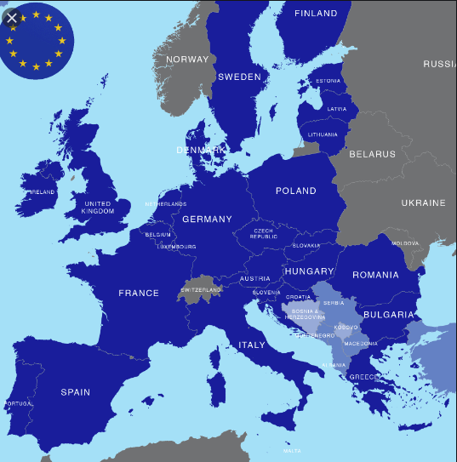

- How do you think World War II influenced the creation of the EEC?
European leaders wanted to work together politically and economically to keep peace and bring unity to countries on the continent of Europe.
- Why do you think the EU’s motto is “Unity in diversity”?
Although there are many countries in the EU, they work together for common goals even though they have different languages and cultures. It is the respect for the differences that joins countries together. Diversity can make the EU stronger because each nation brings with it knowledge and more resources.
Wednesday 20th/05/2020
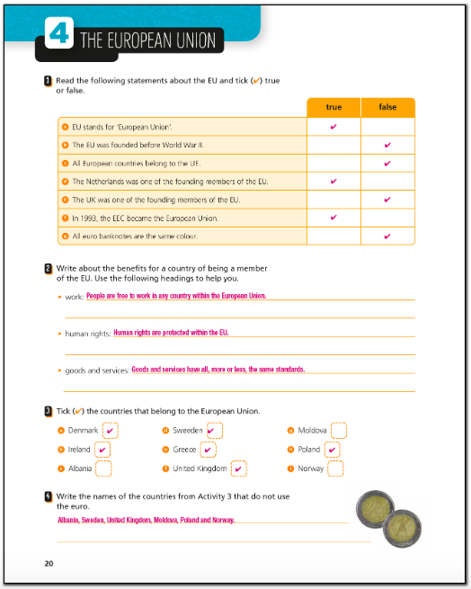
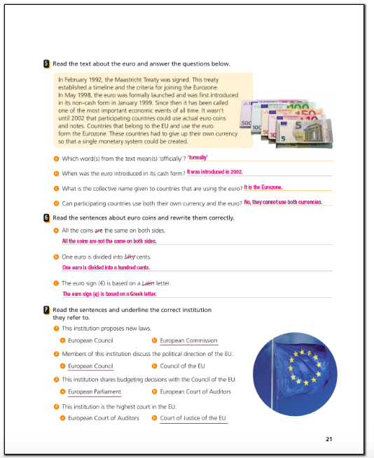

Monday 25th/05/2020
SB P. 61
2. Who was Europa in Greek mythology? How is she connected to the Euro banknotes?
Europa appeared in Greek mythology. She is the mother of Minos of Crete. Europe was named after her. Her face is on euro banknotes as a watermark and hologram.

3.Investigate what GDPR stands for. Who created this law? What does it protect?
GDPR stands for General Data Protection Regulation. The European Commission introduced the law, and it began on 25 May 2018. The law gives European citizens control of their personal data. People can ask a company or social network for the data it has collected about them. People can also ask businesses to delete the data they have stored.
Wednesday 27th/05/2020
AB P.22
