NATURALS

UNIT 6: ELECTRICITY AND MAGNETISM

SOLUTIONS

Thursday 21st/05/2020

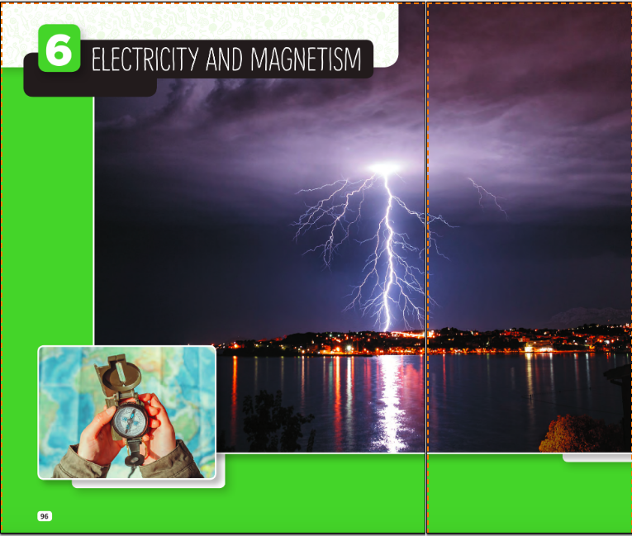

SB.P. 97
- Look at the big photo. What’s happening? What types of energy can you see? How are they different?
There is a storm with lightning. There is electrical energy in the lightning and in the lights of the city. Lightning is natural electricity, and the lights use artificial energy.
- What can happen if we are not careful with electricity? How can we use electrical devices safely?
We can have, or even die from, an electric shock. We must never overload sockets and extension leads. We mustn’t use electrical devices near water. We shouldn’t put anything into the holes of a socket.
- Look at the photo of the compass. Answer these questions in your notebook:
- What do the letters N, S, E and W mean?
N stands for North, S for South, E for East and W for West.
- Where does the needle of the compass always point?
It always points to the North.
- How can a compass help people when they are lost?
It gives people a direction to follow.
- What other inventions can help us find our way around? Do they use electricity?
Paper maps, GPS (Global Positioning System), mobile navigation apps. For the navigation apps your mobile phone must be charged. Noting the position of the Sun or the stars.

Tuesday 26th/05/2020
SB. P.98
- In your notebook, match the words in the box to the photos (1-6) and then to the descriptions (a-f).
- Switch, f: it turns electrical power on and off.
- Wire, e: it can transmit electrical energy.
- Battery, a: it stores energy that we can use.
- LED, b: it is a tiny electrical light bulb.
- Doorbell, c: it is a device that produces sound.
- Magnet, d: it can attract some kinds of metal.

- Which of these objects use magnetism? Then, with a partner, think of other things around us that use magnetism and make a list.
Credit card, hairdryer, food blender and microphone.
Model answer: fridge magnets, doorbell, headphones, audio speakers, MRI imaging.

- Who was Benjamin Franklin? What was his most famous experiment? What did he invent? Share your findings with the class.
Benjamin Franklin was an author, diplomat and inventor. In 1752, he conducted his most famous experiment and demonstrated that lightning is electricity. He designed the first lightning rod to protect buildings from lighting strikes. Some of his other inventions are bifocal glasses, swim fins and Franklin stove.

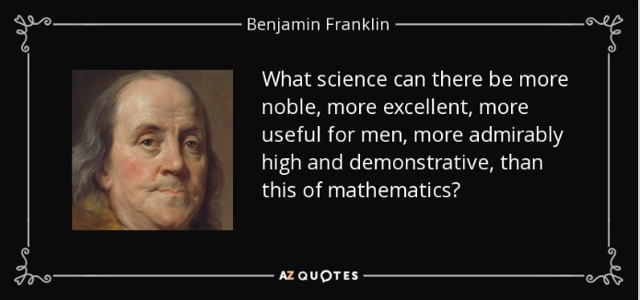

Tuesday 2nd June 2020

