ENGLISH

UNIT 9: SCHOOL: PAST AND FUTURE

Solutions

SB: STUDENTS BOOK
AB: ACTIVITY BOOK

Monday 1st June 2020
SB P. 92

- Look at Sven’s photos. Answer the questions.
- What are the children doing? The children are having different classes at school.
- Do you do these activities in your school? In our school we do some of those activities.
- Which activity would you like to do? Student’s own answer.

- Look and match.
1: chalk
2: blackboard
3: rows of desks
4: easel
5: canvas
6: oil paints
7: goggles
8: laboratory
9: overall
10: whiteboard
11: laptop
12: headphones

- Copy and complete the school concept map.
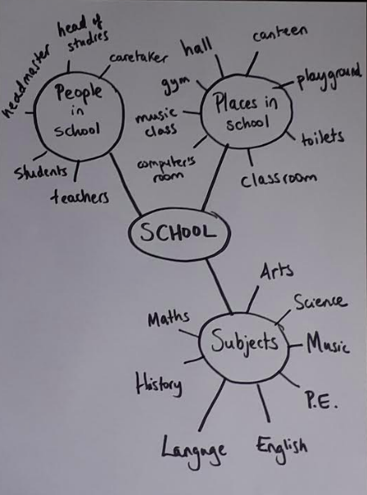

AB. P.90
