ENGLISH

UNIT 9: SCHOOL: PAST AND FUTURE

Solutions

SB: STUDENTS BOOK
AB: ACTIVITY BOOK

Monday 1st June 2020
SB P. 92

- Look at Sven’s photos. Answer the questions.
- What are the children doing? The children are having different classes at school.
- Do you do these activities in your school? In our school we do some of those activities.
- Which activity would you like to do? Student’s own answer.

- Look and match.
1: chalk
2: blackboard
3: rows of desks
4: easel
5: canvas
6: oil paints
7: goggles
8: laboratory
9: overall
10: whiteboard
11: laptop
12: headphones

- Copy and complete the school concept map.
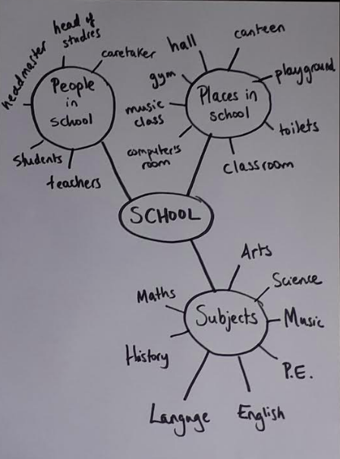

AB. P.90
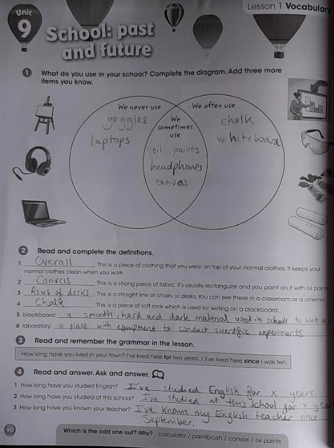

Tuesday 2nd June 2020

ST P.93

Ex. 5 Read the rest of Sven’s message. Do you think this subject is a good idea? Why? Why not?
(Student’s own answer)

READING PET 4

https://es.liveworksheets.com/worksheets/en/English_as_a_Second_Language_(ESL)/Reading_comprehension/PET_Practice_lp182005er

Wednesday 2nd June 2020

ST P.94

- Describe the photo. What is it? Read to find out.
Student’s own answer.
- Read the dialogue again. Ask and answer.
- Does Sven like hearing about the past?
Yes, he does.
- How were the teachers different in the past?
They were a lot stricter.
- How were classrooms different in the past?
They weren’t any laptops or calculators.
- Why do you think pupils used slate in the past?
Student’s own answer.
- Look and learn.
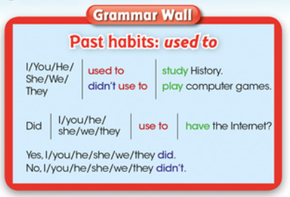

- Read and think. Choose.
THINK ABOUT GRAMMAR
- We use used to when we talk about the present/past.
- We can/can’t use used to when we talk about the present.
- Look at the dialogue in Activity 1 again. Find examples of used to.

- Make true sentences about schools in the past.
(Student’s own answers.)
Model answer: In the past students used to sit in rows in the classrooms, by contrast, students often sit in groups in schools nowadays.

AB P. 91

- Read and complete.
- Teachers didn’t use to use interactive whiteboards in the past.
- Most children used to walk to school fifty years ago.
- Teachers used to be a lot stricter.
- Children used to work in silence in the past.
- Children didn’t use to have laptops forty years ago.
- Teachers used to punish pupils a lot more in the past.

- Write the questions.
- Did you use to go to infant school when you were two?
- Did you use to use a computer when you were four?
- Did you use to have English classes when you were five?
- Did you use to wear an overall when you were six?
- Did you use to do homework when you were eight?

- Do you think schools were better in the past?
Student’s own answer.

