NATURALS

UNIT 5: MATTER AND ENERGY

SOLUTIONS

P. 75
1. Model answer:
Potential energy: energy stored in the lake and in the wood burning in the campfire; light energy: the lamp inside the tent gives light; thermal energy; the campfire and the hot mug provide heat.

2. There is liquid water, snow and steam. In nature, we also find water as ice, in clouds, as fog, as hail or frozen rain, as icicles, etc.

3. Model answer:
a. snow melts if heated
b. liquids evaporate if boiled
c. a chemical reaction with oxygen
d. fossil fuels
e. a mixture consists of one or more substances; not all mixtures are homogenous.

4. Model answer:
We use mechanical energy to make objects work. We use thermal energy to heap up things. We use electrical energy to heat up things. We use electrical energy to provide power to various devices.

5. Pupil’s own answer.

P. 80
1. Heterogeneous mixtures; substances not combined evenly; substances can be separated. Homogeneous substances evenly combined; more difficult to separate substances.

2. a) distillation b) decantation c) filtration d) decantation

P.81
Ex. 3 Discuss the questions:
- Magnets attract magnetic metals.
- Sand sinks in water because it has higher density than water.
- A filter functions by stopping small particles from liquids and gases while letting the liquid or gas pass through.
- We can use decantation to separate oil and water.

AB P. 26
- Match the words to the correct definition:
- A mixture is a physical combination made up of at least two substances.
- A homogeneous mixture is a type of mixture that is uniform in composition.
- A heterogeneous mixture is a type of mixture that is made up of two substances which keep their own properties.
- A pure substance is a material that only has one type of particle.
- Matter is anything that occupies space and has particles.

- Look at the photos and label the substances using words.
- Pure substance
- Heterogeneous mixture
- Homogenous mixture

- What type of method would you use to separate the following substances?
- ground coffee from water: decantation
- paper clips from rubber bands: magnetic separation
- salt from seawater: evaporation
- rice from flour: decantation (sieving)
- water from alcohol: distillation
- iron from sand: magnetic separation

AB. P.27

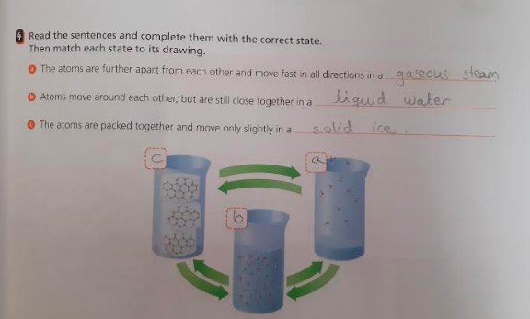

Ex. 5. Look at the picture and explain the changes.
The glass broke and it is an irreversible change

Ex. 6. Explain the following terms:
- Volume: the amount of physical space that an object occupies
- Density: the amount of matter that occupies a space.
- Mass: the amount of matter that an object contains
- Irreversible change: these changes are permanent and cannot be reversed.
- Reversible change: these changes are temporary and can be reversed.

ST. P. 84 & 85

Ex. 1. Discuss the questions about combustion fuels.
- What is produced when wood burns? When wood burns: heat, light, smoke and ash are produced.
- What does burning petrol release? Burning petrol releases carbon dioxide, other gases and solid particles.
- Why is natural gas better than wood? Burning natural gas is cleaner than burning wood.

Ex. 2. What gas is necessary for combustion? What forms of energy does combustion produce? Oxygen is necessary for combustion. Combustion produces heat and light energy.

Ex. 3. How is yoghurt made? Write the steps. Yoghurt is made by adding bacteria to milk. The mixture is heated up. Then it ferments. Then it becomes yoghurt.

Ex. 4. Are these foods fermented by fungi or bacteria?
Fungi: cake.
Bacteria: cheese, olives, chorizo, yoghurt.

Ex. 5. Why do some food and vegetables oxidise? Find information online. How can you prevent food from oxidising? Because they contain an enzyme which reacts with the oxygen in the air; by using food containers, food wrap or freezing it.

Tuesday 12th/May/2020
P.88
Ex. 1. How does light give us information about the world?
When line travels in a straight line and it hits an object, the object absorbs some colours and reflects other. The reflected colours are the ones we see.

Ex. 2. The surface of a lake is a good reflector on calm days, but not on windy days. Why do you think this is?
This is because when light hits a rough surface, the rays of light reflect in many directions producing unclear images.

Ex. 4 How are binoculars and microscopes similar? How are they different? What other devices use lenses?
Both binoculars and microscopes use lenses that refract light; binoculars are two small telescopes put together, using a series of lenses and prisms to magnify things at a distance; A microscope is an instrument to observe very small objects; Other devices are glasses and cameras.

Ex.5 Are there any photovoltaic power stations in your area? How much energy do they produce? Search online for information and share your findings with the class.
Yes, there are several photovoltaic power stations in our area. For example, there is one Cepsa’s station in San Blas, one form Grupo T Solar in Barrio de Salamanca and one fro FF Ventures in Coslada.

P.91
1. Where does thermal energy come from? What do we call this energy when it flows?
Thermal energy comes from moving particles in matter. We call it heat.

3. How is heat insulation used in our everyday life? Give examples.
Model answer: Heat insulation is used for cooking (a frying pan), for keeping warm (a radiator or a jacket), or for double-glazing windows.

4. Search online to find out the boiling points of these substances: alcohol, chlorine, mercury, olive oil and propaine.
Alcohol: 79 degrees
Chlorine: -34.4 degrees
Mercury: 356.9 degrees
Olive oil: 300 degrees
Propane: -42 degrees

Tuesday 19th/05/2020
P.94
1. Copy and complete the graphic.
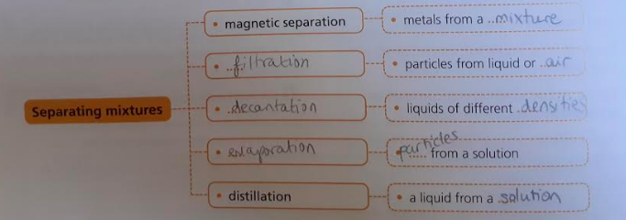

2. Choose the correct option to make true sentences.
a) Ice has a stable volume.
b) Liquid water boils at 100ºC.
c) Steam is water in a gaseous state.
d) Reversible changes can be changed back again.
e) Density is mass divided by volume.
f) Freezing is physical change.

5. Answer the questions about chemical reactions in your notebook.
- What agents produce chemical reactions? Heat and energy.
- What waste does wood combustion produce? Ash, smoke and carbon dioxide.
- How does combustion help us? It produces light and heat.
- How does petrol combustion affect the environment? It causes air pollution.
- How can we reduce the negative effects of burning fuel? By using renewable sources of energy and recycling.

6. What do these objects have in common? How are they different from each other?
- a camera
- a telescope
- glasses
- a microscope
- a projector
- binoculars
All the objects use lenses but different type of lenses: a camera uses different focal length lenses; telescopes, glasses and binoculars all use lenses to make distant objects look larger; a microscope uses convex lenses, but a projector uses concave lenses.

7. Look at the photo in your notebook and describe what is happening with the light.
This type of photograph is called reflection or mirror photography.
The rays of light hit the smooth surface of the river and reflect a very clear image of the bridge, the town and trees.

8. What are the effects of heat in these situations?
- People sweat when the weather is hot. When the sweat dries, people feel cooler. Evaporation.
- If you leave a bowl of ice cream on the table, the ice cream on the table, the ice cream will turn to liquid. Melting.
- Electrical power lines hang lower in hot weather and lighter in cold weather. Expansion.

10. Match the statements below.
- Mechanical energy is the sum of potential and kinetic energy.
- Thermal energy always flows from warmer to cooler objects.
- Chemical energy is released when we digest the food that we eat.
- Light energy can come from both natural and artificial sources.
- Electrical energy is generated at different types of power stations.
- Sound energy is produced from vibrations.

