ENGLISH

UNIT 8: LET’S DREAM

Solutions

SB: STUDENTS BOOK
AB: ACTIVITY BOOK

Monday 11th/05/2020
SB.P.82
- Look at Emma’s photos. Answer the questions: (Student’s own answer- model answers)
  - What can you see in the photos? In the photos you can see people enjoyed free time activities.
  - How do you think the people feel? I think people feel happy enjoying free-time activities.
  - Which activity is the most exiting? In my opinion, the most exiting activity is scuba diving.
- Match the photos.
- Scuba diving
- Coral
- Tropical fish
- Have a nap
- Palm tree
- Hammock
- Wildlife spotting
- Giant tortoise
- Boogie boarding
- Sea kayaking
- Sea lion
- Shore

- Imagine you’re going to visit Galapagos Island. List ten things you’d like to take with you. (Student’s own answer: model answer.)
I’d like to take: a guide book, a mosquito repellent, a pair of binoculars, a swimsuit, a snorkel, a torch, a tent, boots, a first aid kit, a lighter.

AB. P.80
1. Order the words.
1. Palm tree
2. Coral
3. Sea lion
4. Shore
5. Giant tortoise
6. Tropical fish
2. Complete the definitions
1. Scuba diving
2. Have a nap
3. Sea kayaking
4. Hammock
- & 6. Pupil’s own answer

- Read and answer the questions. (Pupil’s own answer.)

SB. P.83
- Read the rest of Eva’s message. Which activity do you think is the best?
(Student’s own message.)

ANSWERS TO PET READING: “China’s Dynasties”
- D
- C
- D
- C

Wednesday 13th/05/2020
SB. P.84
- Describe the photo. What do you think Eva did there?
Model answer: It is a photo of a beautiful tropical beach. Eva cleaned it recently.
- Read and say true or false.
- False. Eva lives in Galapagos Islands.
- True
- False. Callum doesn’t swim in the Pacific Ocean every day.
- True.

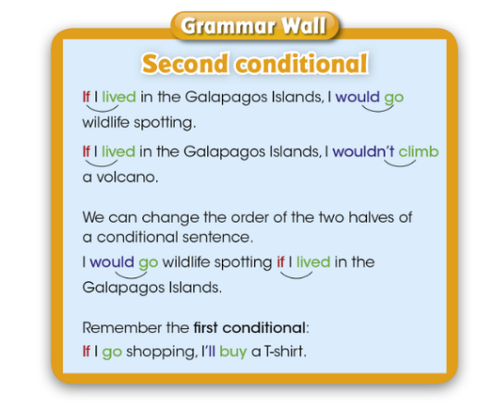

- Think and choose.
- We use the first conditional to talk about something that is probable.
- We use the second conditional to talk about something that is unlikely.

- Look at the dialogue and find examples of the second conditional.
If I lived in the Galapagos Islands I’d swim in the sea every day.
I wouldn’t go to the town centre.
If I lived there I’d go sailing around the islands too.
- Say what you would and wouldn’t do if you lived in the Galapagos Islands.
Pupil’s own answer.

AB. P.81
- Read and circle.
- If I lived in England I’d speak English every day.
- I wouldn’t swim in the sea if I lived in Alaska.
- I’d see kangaroos if I lived in Australia.
- If I saw a giant tortoise I’d be happy.
- I’d feel tired if I hiked to the top of the volcano.
- If I went kayaking I’d wore a life vest.

- Read and complete. Use the second conditional.
- If I lived in France I’d speak French.
- I wouldn’t get tired if I climbed a volcano.
- I’d see tropical fish if I swam in the Galapagos Isalands.
- I’d take lots of photos if I saw a giant tortoise.
- I’d have a nap if I felt tired.
- If I saw an iguana I wouldn’t touch it.

- Read and answer. (Student’s own answer)
- Which activity would you do if you visited the Galapagos Islands?
- What would you take if you visited the Galapagos Islands?
- How would you feel if you swam next to a small shark?

Monday 18th/05/2020
SB. P. 85
- Read and discuss: (Pupil’s own answers)
What can you see on the photo of the right?
Have you ever been sailing?
Do you think it’s an exciting activity? Why? Why not?
What are the dangers of sailing?
- Listen and read.

AB. P. 82
- Remember the story:
- What was the yacht called? It was called Auralyn.
- What attacked the yacht? A whale attacked the yacht.
- How many lifeboats did the couple have? They had two lifeboats.
- Why didn’t the ships see the lifeboats? Because the lifeboats were tiny.
- How long were the couple in the lifeboats? They were in the lifeboat for 117 days.
- Who finally rescued the couple? A Korean fishing boat rescued them.

- What do you think of the story? (Pupil’s own answer)
- Find about Ecuador with your family.
- What’s the capital of Ecuador? Quito
- Which line goes through Ecuador? The Equator
- What’s Cotopaxi? A volcano
- How many islands make up the Galapagos Islands? 14 major islands and many smaller islands.
- How were the islands formed? By volcanic activity.

Monday 19th/05/2020
SB. P.86

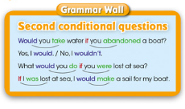
AB. P.83
- Complete the questions and answer.
- Would you be scared if you were a snake?
- Would you cry if you cut your finger?
- Would you be happy if you met a film star?
- Would you eat fish and chips if you visited London?
- Would you remember your friends if you were famous?
- Would you go skiing if you lived in Canada?

- Write the questions and answer.
- What would you do if you won a lot of money? If I won a lot of money I would buy a big house in the countryside.
- What would you do if you got lost? If I got lost I would activate google maps.
- How would you feel if you lost your bag? If I lost my bag I would feel terribly worried.
- Where would you go if you visited Paris? If I visited Paris I would visit the Louvre Museum.
- Where would you live if you were a famous person? If I were a famous person I would still live in Moratalaz.

4. Write questions about imaginary situations. Model answers.
- What would you do if you found a lost dog?
- What would you do if you met your favourite music band?
- Student’s own questions.

Wednesday 20th/05/2020
SB. P.87
Copy vocabulary

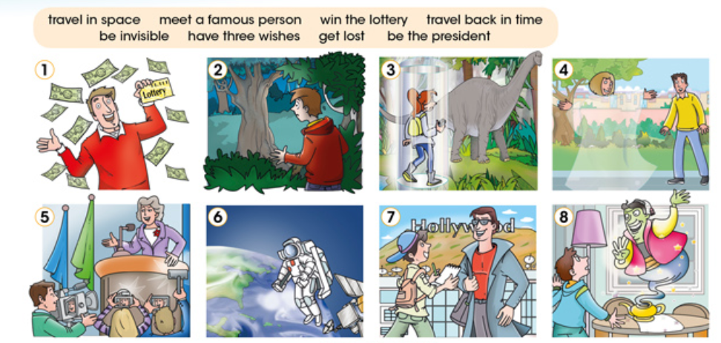

AB. P.84
- Write the missing letters. Tick the things you’d like to do.
- Win the lottery
- Have three wishes
- Get lost
- Travel back in time
- Be invisible
- Be the president
- Travel in space
- Meet a famous person

- Read the text and the sentences. Write A (right) or B (wrong).
- Most of the children wanted to visit a place close to their home. B
- The most popular destinations were places with beaches. A
- Some of the children wanted to visit a big city. A
- All of the children wanted to have a good time. B

- Read and learn.
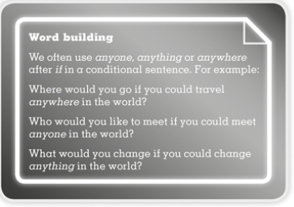

4. Work with a partner. Look at the word-building box and write the answers.
- If I could travel anywhere in the world, I’d travel to…
- If I could meet anyone in the world I’d meet…
- If I could change anything in the world I’d change…

Thursday 21st/05/2020
SB. P. 88
Before you read
- Read and discuss: (Student’s own answers)
- Do you write a diary? What things do you write about?
- Have you ever read a book that was a diary?
- Was it fictional or was it autobiographical?
- What events did the writer describe?

- Look at the sketches in the diary. Where do you think the writer is? Read and find out. (Student’s own answers.)
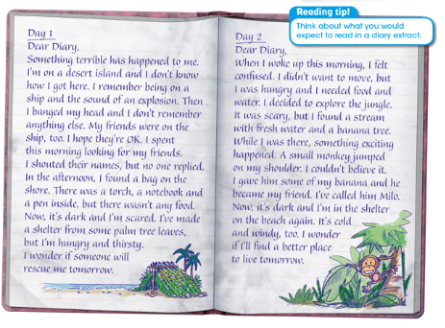

- What do you think? (Student’s own answers)
- Is this an interesting diary?
- Which information is the most interesting?
- Would you like to change places with the writer? Why/Why not?

AB. P.85
After you read
- Read and order the events.
I explored the jungle: 8
I found food and drink: 9
There was an explosion: 2
I was sailing on a ship: 1
I banged my head: 3
I found a bag: 6
I built a shelter: 7
I made friends with a monkey: 10
I woke up on the beach: 4
I looked for my friends: 5

- Read and answer the questions:
- How does the writer feel at the end of the first day?
The writer felt scared at the end of the first day.
- How would you feel if you woke up on a desert island?
(Student’s own answers)
- What did the writer eat on the second day?
The writer ate bananas on the second day.
- What would you eat if you were on a desert island?
(Student’s own answers)

- Whose diary would you like to read? Why?
(Student’s own answers)

Monday 25th/05/2020
SB P.89
- Read and answer.
- Look at the diary extract in activity 2. How many days have passed since the last diary extract? 5 days.
- What have you done on this time? (Student’s own answer)
- What do you think the writer has done?
- Read the diary extract to check your answers.
- Read the diary extract again. Find the following:
- When the writer wrote the diary: Day 7
- Some interesting information: He found a suitcase full with useful objects.
- Three time references: now, today, this morning, in the afternoon, afterwards
- Three different tenses: present simple, present continuous, past simple, past continuous, present perfect
- The writer’s feelings: Happiness.
- A personal reflection or thought: (Student’s own answer)

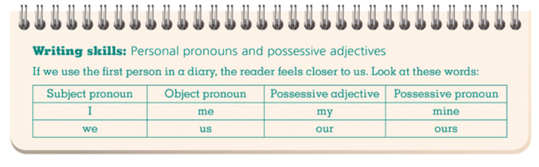

AB P. 86
- Complete the sentences.
- We built this ht. It’s ours.
- The coconut me on my head and I felt dizzy.
- Our boat sank and now we are on a desert island.
- All the island is mine, I’m the king of the island.
- My friends were on the boat and I don’t know where they are.
- Hands off. This map is ours. We found it.

- Plan your diary extract. (Student’s own answer)
- Now write a diary extract. (In your diary.)
- Then read your diary and check your work. (Student’s own answers.)
- I’ve included the date or dates
- I’ve used the first person
- I’ve written the events in order
- My diary extract includes interesting information
- I’ve described my feelings
- My diary extract includes a reflection

