ENGLISH

UNIT 8: LET’S DREAM

Solutions

SB: STUDENTS BOOK
AB: ACTIVITY BOOK

Monday 11th/05/2020
SB.P.82
- Look at Emma’s photos. Answer the questions: (Student’s own answer- model answers)
  - What can you see in the photos? In the photos you can see people enjoyed free time activities.
  - How do you think the people feel? I think people feel happy enjoying free-time activities.
  - Which activity is the most exiting? In my opinion, the most exiting activity is scuba diving.
- Match the photos.
- Scuba diving
- Coral
- Tropical fish
- Have a nap
- Palm tree
- Hammock
- Wildlife spotting
- Giant tortoise
- Boogie boarding
- Sea kayaking
- Sea lion
- Shore

- Imagine you’re going to visit Galapagos Island. List ten things you’d like to take with you. (Student’s own answer: model answer.)
I’d like to take: a guide book, a mosquito repellent, a pair of binoculars, a swimsuit, a snorkel, a torch, a tent, boots, a first aid kit, a lighter.

AB. P.80
1. Order the words.
1. Palm tree
2. Coral
3. Sea lion
4. Shore
5. Giant tortoise
6. Tropical fish
2. Complete the definitions
1. Scuba diving
2. Have a nap
3. Sea kayaking
4. Hammock
- & 6. Pupil’s own answer

- Read and answer the questions. (Pupil’s own answer.)

SB. P.83
- Read the rest of Eva’s message. Which activity do you think is the best?
(Student’s own message.)

ANSWERS TO PET READING: “China’s Dynasties”
- D
- C
- D
- C

Wednesday 13th/05/2020
SB. P.84
- Describe the photo. What do you think Eva did there?
Model answer: It is a photo of a beautiful tropical beach. Eva cleaned it recently.
- Read and say true or false.
- False. Eva lives in Galapagos Islands.
- True
- False. Callum doesn’t swim in the Pacific Ocean every day.
- True.

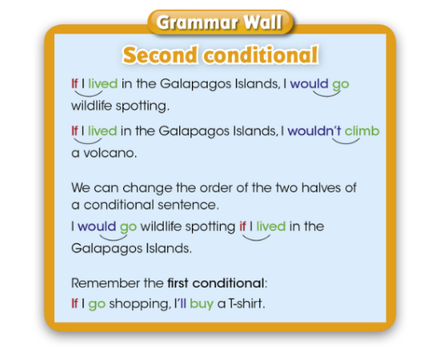

- Think and choose.
- We use the first conditional to talk about something that is probable.
- We use the second conditional to talk about something that is unlikely.

- Look at the dialogue and find examples of the second conditional.
If I lived in the Galapagos Islands I’d swim in the sea every day.
I wouldn’t go to the town centre.
If I lived there I’d go sailing around the islands too.
- Say what you would and wouldn’t do if you lived in the Galapagos Islands.
Pupil’s own answer.

AB. P.81
- Read and circle.
- If I lived in England I’d speak English every day.
- I wouldn’t swim in the sea if I lived in Alaska.
- I’d see kangaroos if I lived in Australia.
- If I saw a giant tortoise I’d be happy.
- I’d feel tired if I hiked to the top of the volcano.
- If I went kayaking I’d wore a life vest.

- Read and complete. Use the second conditional.
- If I lived in France I’d speak French.
- I wouldn’t get tired if I climbed a volcano.
- I’d see tropical fish if I swam in the Galapagos Isalands.
- I’d take lots of photos if I saw a giant tortoise.
- I’d have a nap if I felt tired.
- If I saw an iguana I wouldn’t touch it.

- Read and answer. (Student’s own answer)
- Which activity would you do if you visited the Galapagos Islands?
- What would you take if you visited the Galapagos Islands?
- How would you feel if you swam next to a small shark?

