MATTER AND ENERGY
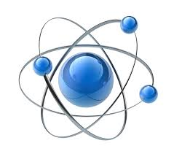

NATU
GLOSSARY 2
EXERCISES 3
Pupils Books: 3
Educaplay: Mixtures: 4
Activity Book 5
Photos Mixtures 6

GLOSSARY

ENGLISH | CASTELLANO
Receipt | Recibo

EXERCISES

Pupils Books:
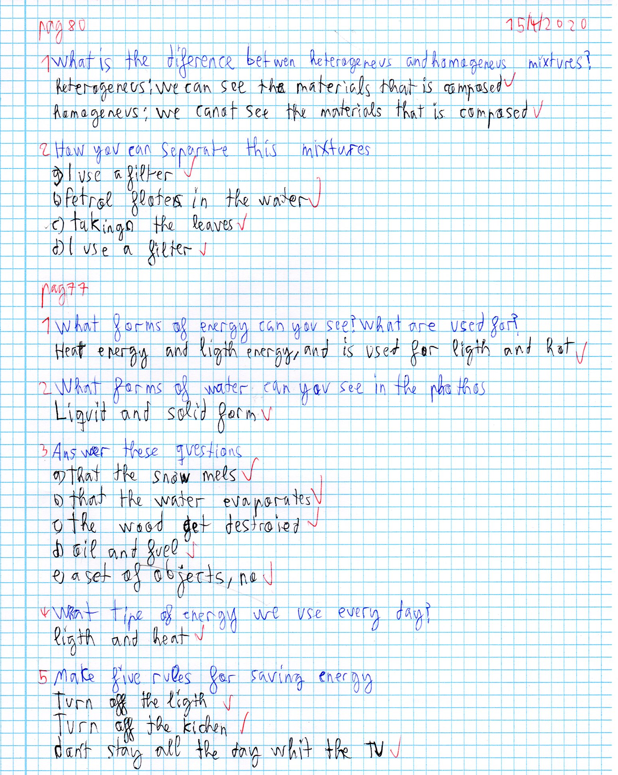

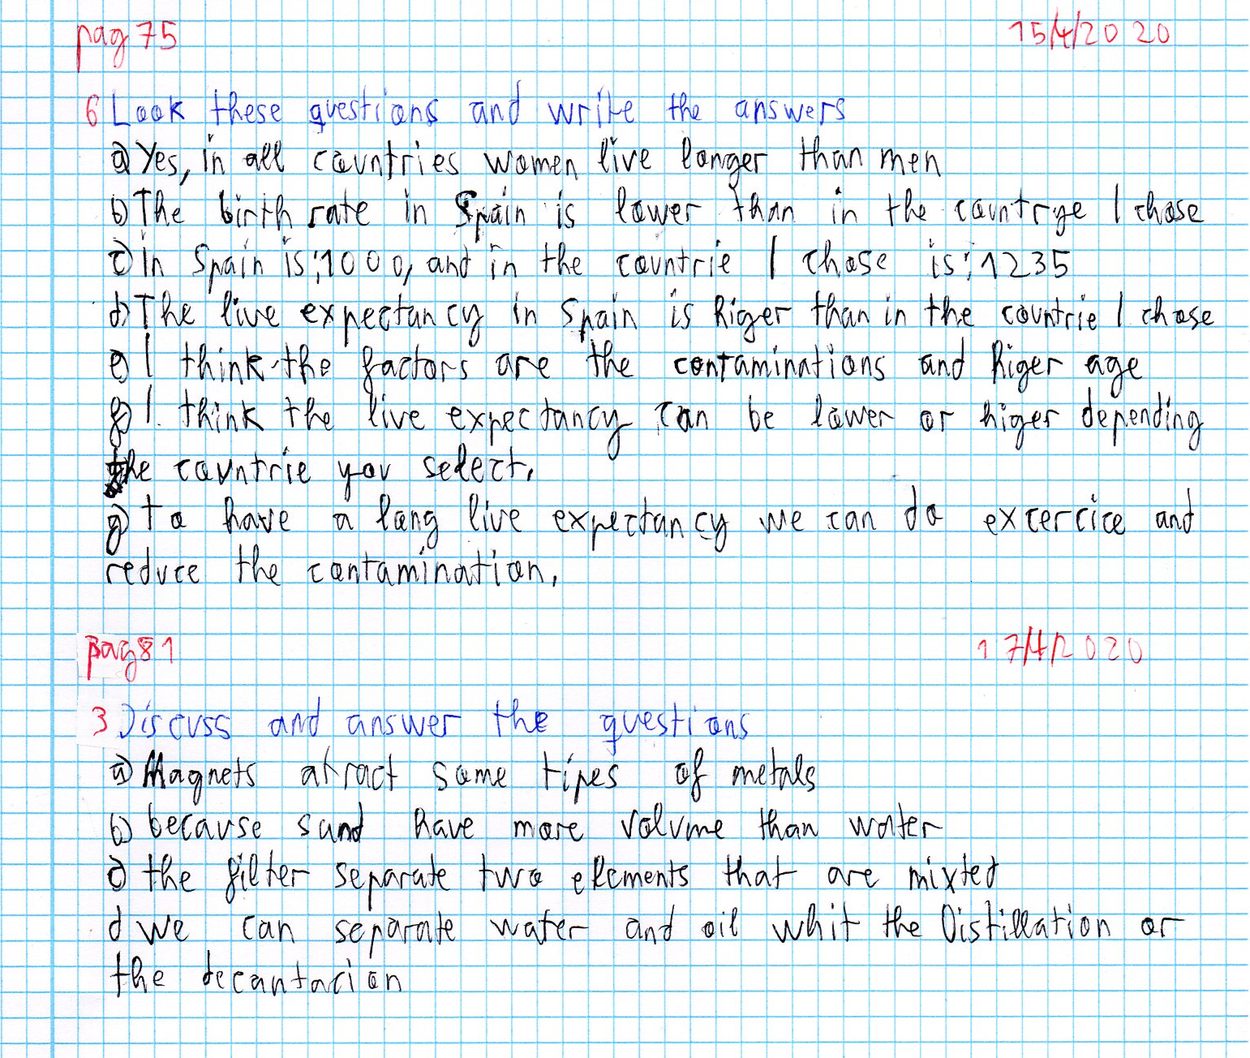

Educaplay: Mixtures:

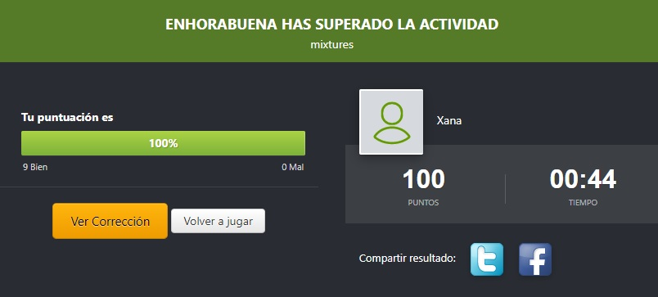

Activity Book

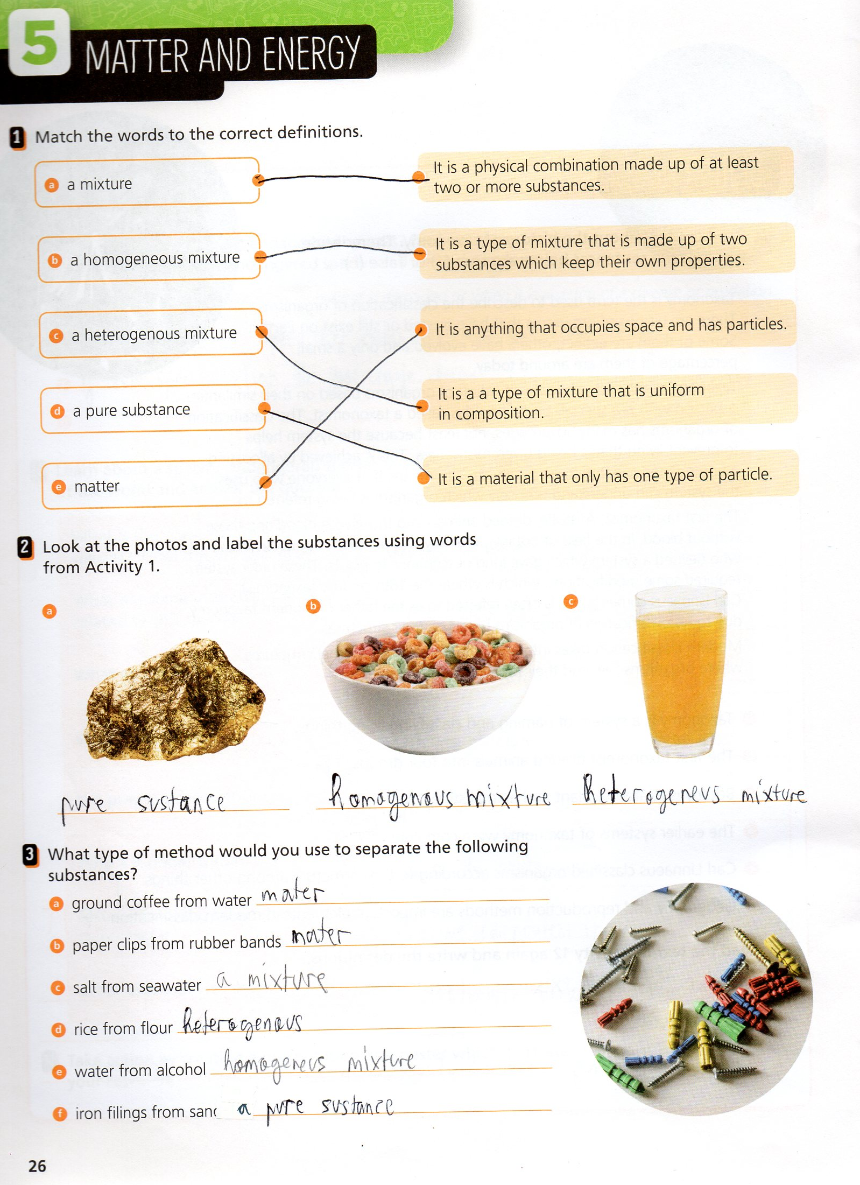

Photos Mixtures

Homogeneous
BEFORE MIX | AFTER MIX
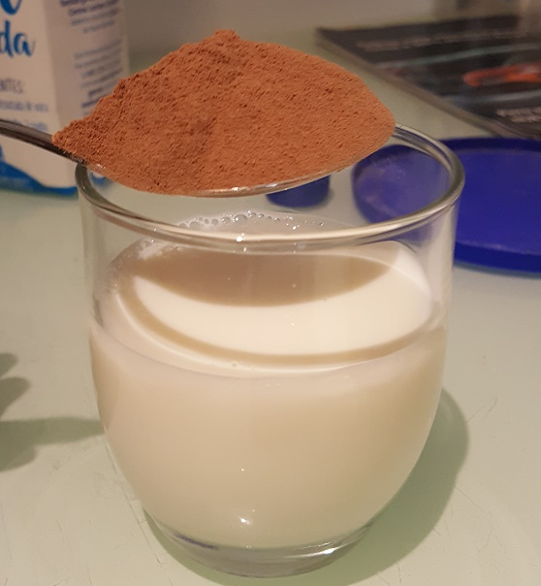 | 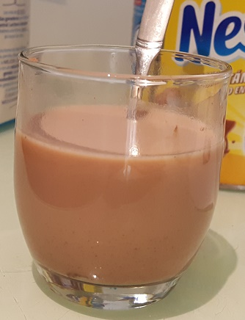

Heterogeneous
BEFORE MIX | AFTER MIX
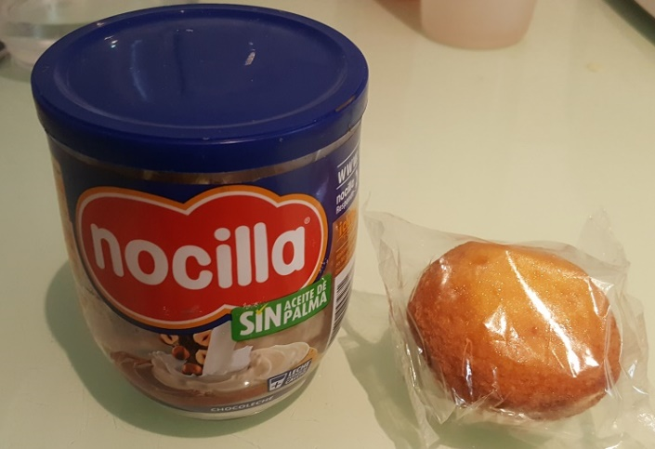 | 