SPANISH
POLITICAL ORGANISATION

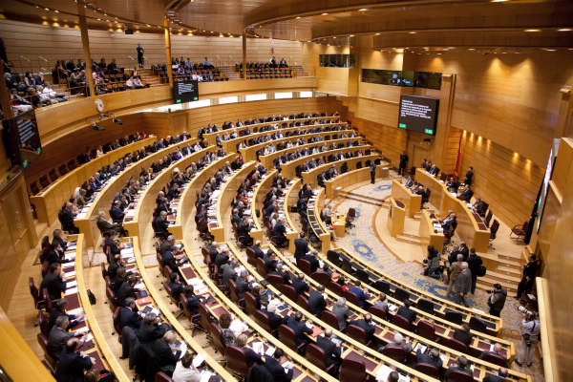

SOCI
GLOSSARY 3
EXERCISE 4
Pag. 43 4
1.- 4
2.- 4
3.- 4
4- 4
Pag 44 5
1- 5
2- 5
3.- 5
4.- 6
5.- 6
Pag. 46 6
1.- 6
2.- 7
3.- 7
4.- 7
5.- 7
MIND MAP 8

GLOSSARY

ENGLISH | CASTELLANO
Minesterial parlaments | Parlamento Ministerial
Parlamentary | Parlamentario
Parties | Partido
Decentralised
Citizens | Ciudadanos
Ballot | Papeleta
Campaing | Campaña

EXERCISE

Pag. 43

1.-
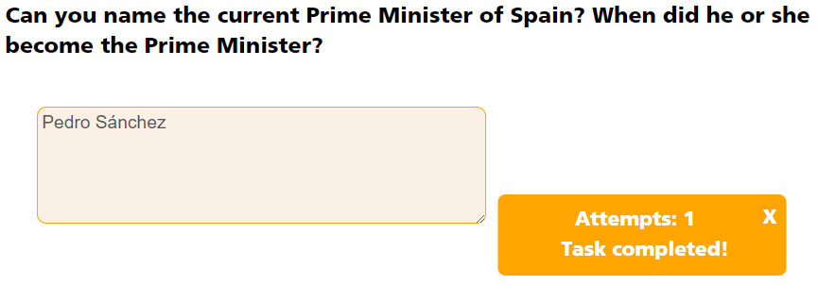

2.-
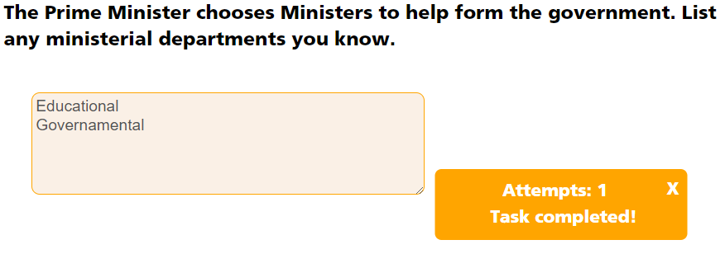

3.-

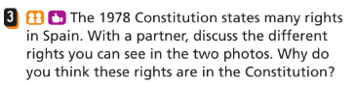
To the good of the people

4-

All people older then eigthteen years old. It isn`t obligatory.

Pag 44


1-
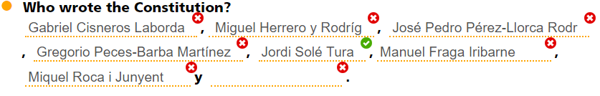

Unión de Centro Democrático , Partido Socialista Obrero Español, Partido Comunista de España , Minoría Catalana

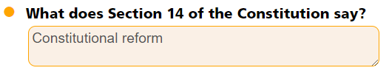

2-
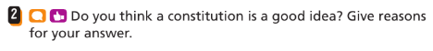
Yes, I think so.
Because The Constitution help to understand the laws.

3.-
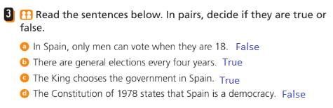

4.-




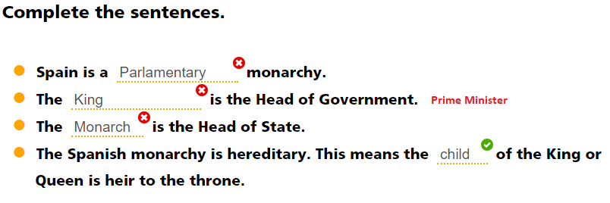

5.-

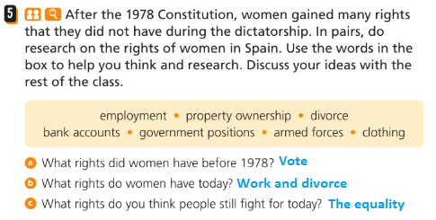

Pag. 46

1.-
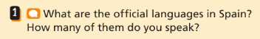
Spanish is the oficial lenguage and Catalán, euskera and gallego.
I speak two lenguage, english an spanish.

2.-

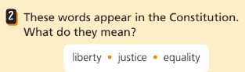
Liberty: Is the hability to do as one pleases
Equalyty: All people have all the rigths.
Justicie: Is a comon good valve determinated by the society.

3.-

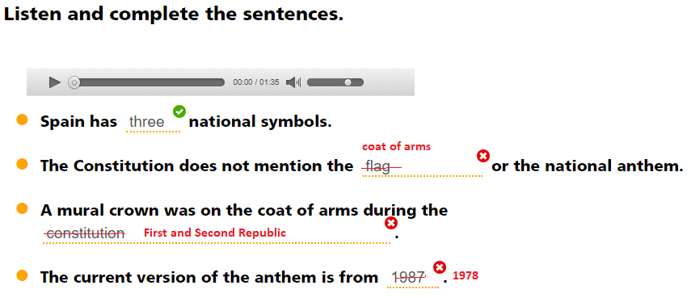

4.-
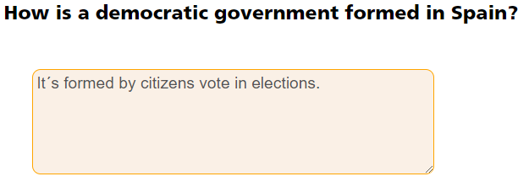

5.-
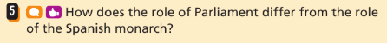
The Parlament make laws and the Monarchy represents Spain but can not make laws.

MIND MAP

The Constitution of 1978
- Was made on 6 December 1978
- It’s foundation of democracy in Spain.
- The Constitution`s values are:
  - Freedom
  - Justice
  - Equality

The Constitution defines Spain as a:
- Democratic State: Citizens can vote.
- Territorially decentralised state.
- Parlamentary Monarchy. Represents all spanish

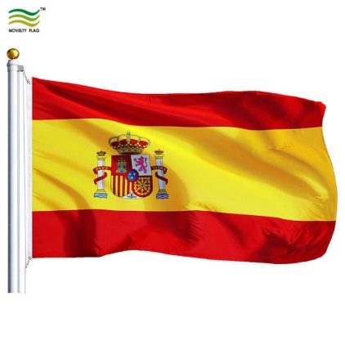
This is national flag

Lenguages:
- The official language is Spanish
- Constitution recognises then next languages:
  - Galician
  - Basque
  - Catalan
  - Valencian
The Constitution says all citizens are equal.
Rights and responsibilities
- Rights: Is something a person is allowed to do
- Responsabilities: It`s an obligation to do something.

Elections
Citizens vote in elections to help form national and local goverments
All Spanish citizens aged 18 and older have the right to vote.

- Generelly autonomous community and muicipal elections are every four years.
- The political parties make their campaing before an election
- The vote is secret and anonymous.
- The party with the most votes wins the election.

The spanish monarchy
The spanish monarchy, represents Spain in international relations, but doesn`t approveds laws.
The Princess of Asturias is heir to the throne from her father, because she hasn´t brothers.

