SOCIALS

UNIT 3: SPANISH POLITICAL ORGANISATION

Solutions

P. 43
1. The current Prime Minister of Spain is Pedro Sánchez. He became Prime Minister in 2018, in June. And he was re-elected 2019, in April.

2. Possible answers:
- Parliamentary Relations and Equality
- Foreign Affairs
- The UE and Cooperation
- Justice
- Defence
- Treasury
- Home Affairs
- Public Workers
- Education
- Work, Migration and Social Security
- Industry, Trade and Industry
- Agriculture
- Fisheries and Food
- Territorial Policy and Public Function
- Ecological Transition
- Culture and Sport
- Economy and Business
- Health, Consumption and Social Well being
- Science, Innovation and Universities

3. Healthcare and Education. (Pupil’s own answer)

4. Citizens aged 18 and over can vote in Spain. Voting is both: a right and an obligation.

P. 44
1. a) and
b) Gabriel Cisneros (UCD), Miguel Herrero y Rodríguez de Miñón (UCD), Manuel Fraga (AP), Gregorio Peces-Barba (PSOE), Miguel Roca (Minoría Catalana) and Jordi Solé Tura (PSUC)
c) Spaniards are equal before the law
d) 6 December 1978
e) 27 December 1978

2. Pupil’s own answer.

3. a) F. All citizens over 18 can vote.
b) T
c) F. The people choose the government.
d) T

4. a) parliamentary
b) Prime Minister
c) Monarch
d) Child

5. Pupil’s own answer.

P. 46 and 47
1. Spanish, Galician, Basque, Catalan, Valencian: Pupil’s own answer.
2. Liberty- freedom; justice- use of fair laws; equality-the same rights for everyone
3. a)three
b) coat of arms
c) First and Second Republic
d) 1978
4. In Spain, the government is formed when citizens over 18 vote in elections. The party with the most votes wins the elections. The people of the nation choose the party that will govern.
5. Pupil’s own answer. Model answer: Parliament is responsible for making and approving laws, whereas the Spanish monarch can represent Spain internationally but cannot create new laws.

P.48

DIVISION OF POWERS

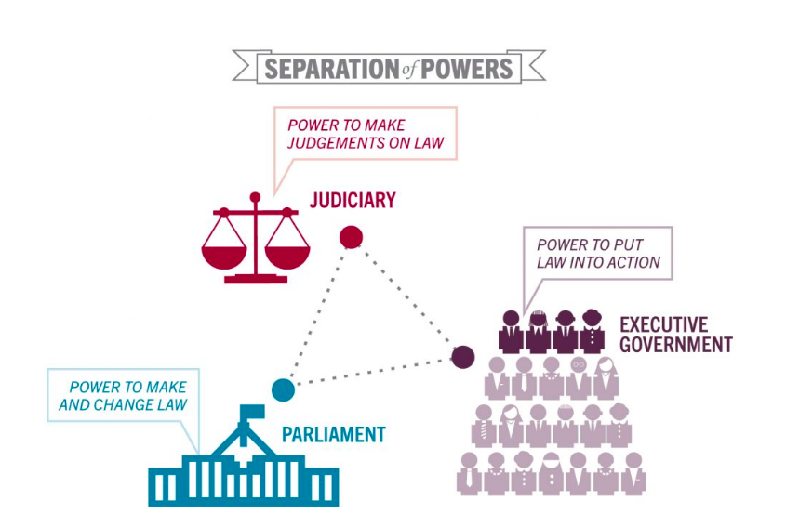

CURRENT MINISTERS OF SPAIN AND THEIR MINISTERS

Portfolio | Minister | Term
Prime Minister | Pedro Sánchez MP | 2018–present
First Deputy Prime Minister  Minister of the Presidency  Secretary of the Council of Ministers | Carmen Calvo MP | 2018–present
Second Deputy Prime Minister  Minister of Social Rights and 2030 Agenda | Pablo Iglesias MP | 2020–present
Third Deputy Prime Minister  Minister of Economic Affairs and Digital Transformation | Nadia Calviño | 2018–present
Fourth Deputy Prime Minister  Minister for the Ecological Transition and Demographic Challenge | Teresa Ribera | 2018–present
Minister of Foreign Affairs, European Union and Cooperation | Arancha González Laya | 2020–present
Minister of Justice  First Notary of the Kingdom | Juan Carlos Campo Moreno | 2020–present
Minister of Defence | Margarita Robles | 2018–present
Minister of Finance  Spokesperson of the Government | María Jesús Montero MP | 2018–present
Minister of the Interior | Fernando Grande-Marlaska | 2018–present
Minister of Transports, Mobility and Urban Agenda | José Luis Ábalos MP | 2018–present
Minister of Education and Vocational Training | Isabel Celaá | 2018–present
Minister of Labour and Social Economy | Yolanda Díaz MP | 2020–present
Minister of Industry, Trade and Tourism | Reyes Maroto | 2018–present
Minister of Agriculture, Fisheries and Food | Luis Planas | 2018–present
Minister of Territorial Policy and Civil Service | Carolina Darias | 2020–present
Minister of Culture and Sport | José Manuel Rodríguez Uribes | 2020–present
Minister of Health | Salvador Illa | 2020–present
Minister of Science and Innovation | Pedro Duque | 2018–present
Minister of Consumer Affairs | Alberto Garzón MP | 2020–present
Minister of Equality | Irene Montero MP | 2020–present
Minister of Inclusion, Social Security and Migration | José Luis Escrivá | 2020–present
Minister of Universities | Manuel Castells Oliván | 2020–present
P. 52
Ex. 1 Complete the table:

Judicial power | Legislative power | Executive power
Judges and magistrates | Parliament and Congress of Deputies | Prime Minister and the Ministers
They ensure that the laws are obeyed. | They develop and vote on laws. | They make decisions about domestic and foreign policy.

Ex. 3 Put the events in the correct order:
1-b
2-d
3-c
4-a
5-e

Ex. 4Research.
- “Further beyond”.
- Carlos I (Carlos V of Germany)
- Pillars of Hercules
- The Pillars of Hercules was the high land in the Strait of Gibraltar (one in Gibraltar and the other possibly in Morocco). They were a symbol that marked the end of the Ancient Greek world. The Pillars of Hercules and the phrase “further beyond” refer to the exploration of the Americas.

AB. P. 14

1. Complete the text using the words in the box.
The Constitution defines Spain as a:
- Democratic State: people can vote for representatives in government.
- Territory decentralised state: this outlines the right of the autonomous communities to self-govern.
- Parliament monarchy: the monarch represents the country as the Head of State, but the Parliament is responsible for making and approving laws.

2. Read and say true or false:
a) T
b) T
c) F
d) T
e) F

