NATURALS

UNIT 5: MATTER AND ENERGY

SOLUTIONS

P. 75
1. Model answer:
Potential energy: energy stored in the lake and in the wood burning in the campfire; light energy: the lamp inside the tent gives light; thermal energy; the campfire and the hot mug provide heat.

2. There is liquid water, snow and steam. In nature, we also find water as ice, in clouds, as fog, as hail or frozen rain, as icicles, etc.

3. Model answer:
a. snow melts if heated
b. liquids evaporate if boiled
c. a chemical reaction with oxygen
d. fossil fuels
e. a mixture consists of one or more substances; not all mixtures are homogenous.

4. Model answer:
We use mechanical energy to make objects work. We use thermal energy to heap up things. We use electrical energy to heat up things. We use electrical energy to provide power to various devices.

5. Pupil’s own answer.

P. 80
1. Heterogeneous mixtures; substances not combined evenly; substances can be separated. Homogeneous substances evenly combined; more difficult to separate substances.

2. a) distillation b) decantation c) filtration d) decantation

P.81
Ex. 3 Discuss the questions:
- Magnets attract magnetic metals.
- Sand sinks in water because it has higher density than water.
- A filter functions by stopping small particles from liquids and gases while letting the liquid or gas pass through.
- We can use decantation to separate oil and water.

AB P. 26
- Match the words to the correct definition:
- A mixture is a physical combination made up of at least two substances.
- A homogeneous mixture is a type of mixture that is uniform in composition.
- A heterogeneous mixture is a type of mixture that is made up of two substances which keep their own properties.
- A pure substance is a material that only has one type of particle.
- Matter is anything that occupies space and has particles.

- Look at the photos and label the substances using words.
- Pure substance
- Heterogeneous mixture
- Homogenous mixture

- What type of method would you use to separate the following substances?
- ground coffee from water: decantation
- paper clips from rubber bands: magnetic separation
- salt from seawater: evaporation
- rice from flour: decantation (sieving)
- water from alcohol: distillation
- iron from sand: magnetic separation

AB. P.27

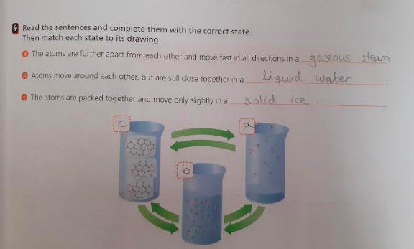

Ex. 5. Look at the picture and explain the changes.
The glass broke and it is an irreversible change

Ex. 6. Explain the following terms:
- Volume: the amount of physical space that an object occupies
- Density: the amount of matter that occupies a space.
- Mass: the amount of matter that an object contains
- Irreversible change: these changes are permanent and cannot be reversed.
- Reversible change: these changes are temporary and can be reversed.

