ENGLISH

UNIT 7: BUYING AND SELLING

Solutions

SB: STUDENTS BOOK
AB: ACTIVITY BOOK

SB. P. 72
- Pupil’s own answer.

- 1. Purse
2. Credit card
3. Coins
4. Banknotes
5. Price tag
6. Receipt
7. Customer
8. Cashier
9. Till
10. Spend money
11. Save money
12. Moneybox

AB. P. 70
- Puzzle
- Banknotes
- Cashier
- Moneybox
- Purse
- Receipt
- Till
- Coins
- Price tag

- Definitions:
- Customer
- Spend money
- Credit card
- Save money
- Person who registers the products that the customer buys in the cash register.
- Metal money

- Grammar point.

- Student’s own answer.

SB. P. 74
- Because he is going to take it to the “almost-new” sale.
- True or false:
- F. The prices are cheaper/lower than in the shops.
- T
- T
- T

Ex. 6. Make sentences:
- The blue T-shirt isn’t as expensive as the red one.
- The bag isn’t big enough for the plant.
- The boy isn’t tall enough to reach the milk.
- The boy isn’t as old as the girl.

AB. P.71
- Complete
1. As
2. Enough
3. Too
4. Enough
5. Too
6. As

- Write sentences:
- The lemonade bottles aren’t as big as the cokes.
- It’s too hot.
- John’s new boots are too uncomfortable.
- Laura isn’t tall enough to write the date on the blackboard.

4.Pupil’s own answer.

P. 72
1. Answer the questions:
1. She went to Puerto Rico.
2. Because she was shocked to see how poor were the people.
3. She bought the materials in Puerto Rico and sold it in the USA.
4. She worked with the craftspeople for 30 years.
5. The farmers grow coffee, sugar bananas and other kinds of food.
6. Organisations help the farmers by making sure they are paid fairly.

4. Find out about USA
1. The capital city is Washington D.C.
2. The largest city as well as the coldest is Alaska.
3. The second most spoken language in USA is Spanish.
4. The Statue of Liberty has seven points in it’s crown.
5. The Gateway is in St. Louis, Missouri, and it looks like an arch.

AB. P. 73
Ex. 1. Circle:
- If it rain on Sunday we won’t play basketball.
- If you eat junk food everyday, you won’t be healthy.
- Maisie won’t win the race if she runs so slowly.
- Mum will take us to the cinema if we help her tidy the house.
- If I sell the food I will go and get some more.

Ex. 2. Complete:
- will you do + aren’t
- will it happen + go
- will you do + is
- will your mum say + sees
- will you do + don’t find

Ex. 4. Student’s own answer. Model answers:
  - If it rains on Saturday I won’t water the plants.
  - If I go to a restaurant tomorrow I will eat pizza.
  - If I go to the cinema on Sunday I will see a Spanish film.
P. 74
Ex. 1
- The wheel is loose.
- The mirror is cracked.
- The racket is bent.
- The T-shirt is torn.

Ex. 2: 1 A; 2 B; 3 B; 4 C

Ex. 4 Adjetives:
-y: messy, bossy, crazy
-ous: dangerous, fabulous, miraculous
-ful: cheerful, beautiful, colourful

P. 76
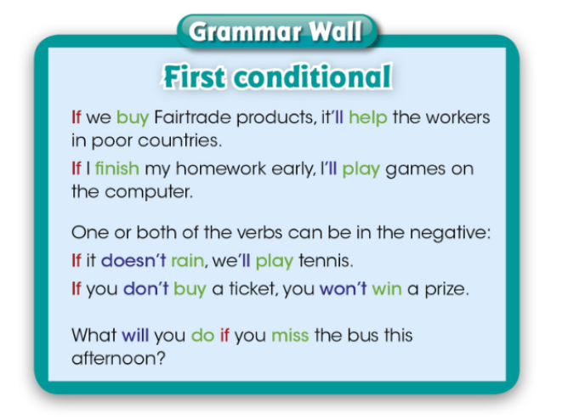
Ex.4 Find other examples of first conditional.
“If we buy Fairtrade products, it will help the workers in poorer countries.”

P. 78
Ex. 1 Read and discuss:
- Where have you seen adverts for these things?
Breakfast cereals: in the morning on TV.
Cars: in big posters on the road.
- What do adverts try to do? They try to convince you to buy something.
- When have adverts persuaded you to do something?
(Student’s own answer).

Ex. 2 (Student’s own answer.)

Ex. 3
- Did you change your mind after reading the text? Yes I did. /No, I didn’t.
- Which phrases in the adverts will help sell the items most?
You’re missing out, buy before we run out, the coolest, can’t be beaten, this isn’t just any boat, be quick, they’ll sell quickly…
- Do you think everything in the adverts is true? (Probably not.)

P. 75
Ex. 1
- You don’t have to push yourself along with your feet when you use the Tiger Waveboard.
- You receive a free DVD of special tricks when you buy the Swoop Stunt Kite.
- You can use the Splash 500 on rough water as well as in calm lakes.
- The Tiger Waveboard is excellent for active teenagers.
- The adverts that the Splash 500 and the Tiger Waveboards are easy to use.

Ex. 2 Complete the sentences:

- The Splash 500 is made of tough plastic so it can be used on rough water.
- There’s a special offer on the Splash 500 boats so you must buy now before they sell them all.
- It takes minutes to learn to use the Tiger Waveboard so you will have fun for years.
- The Swoop Stunk Kite’s sail is made up of strong polyester so it won’t rip.

Ex. 4 Student’s own answer.

P. 79
Ex. 1. Match the words to the definitions:
- Quote: some words said by another person.
- Encourage: to suggest that someone does something that you think would be good.
- Slogan: a short phrase that’s easy to remember and is used to advertise something.
- Bargain: something you buy that costs much less than usual.

Ex. 3. Read the advert again. Answer the questions:
- Read the names of the product. Which word is spelled incorrectly? Why do you think that is? “Supa” is spelled incorrectly. It should be “super” instead of “supa”. The reaon is that they misspell it just for fun.
- Is the slogan memorable? Why? Why not? It is memorable and you can remember it easily because it’s funny.
- Why does the advert include a quote from a famous person? It includes a quote from a famous person to make it more convincing and attractive.
- How many adjectives can you find? What kind of adjectives are they?
Adjectives: new, boring, slow, extra-light, comfortable, super-smooth, sensational, quick. They are describing adjectives.

P. 78
Ex. 1. Complete the words:
- Cashier
- Purse
- Price tag
- Till
- Save money
- Moneybox
- Customer
- Coins

Ex.2. Imagine you are returning four different things to a shop. Write sentences. Use the adjectives.
- I’m sorry. I bought these sunglasses yesterday, but when I got home I realized they were cracked.
- I didn’t realise that the dress was stained until I put it on.
- I also think that the umbrella is a bit bent.
- In addition, I can’t believe I hadn’t noticed before that this shirt was ripped.

Ex. 3. Complete the sentences for you.
- We’re too young to smoke.
- We’re not strong enough to lift that by ourselves.
- Our class is not as decorated as the other one.
- We’re not small enough to fit in there.

Ex. 4. Complete the sentences. Use the first conditional.
- If it rains all day, we’ll have to cancel the match.
- If my class wins the competition we’ll through a big party.
- If you do exercise everyday you will loose weigh.
- If my friend comes to my house this evening we ‘ll watch a film.
- If we miss the bus we’ll be late.

Ex. 5. Read, remember and answer the questions.
- What three objects were advertising in this unit? A skate, a kite and a boat.
- What do we call the text which is used to sell an object? Advert.

Ex. What’s the mystery word?
The mystery word is: receipt.
Definition: the proof that details the costs of a product.

